LM Report Asistent – User’s Guide

Installation Guide

Table of contents:

1 Introduction 3
2 License 3
3 Installation process 4
4 Launching the LM-RA program 10
5 Uninstalling LM-RA 11

Introduction

This document contains the information required to install LM-Report Asistent (further just LM-RA) program, version 1.0.

There are two versions of installation package available:

- Full version
  - This version contains two plugins – LMplugin (LISp-Miner) and FEplugin (Ferda Data Miner).
- Lite version
  - This version contains just LMplugin.

The “lite” version is determined for using on systems, where .NET Framework is not installed. FEplugin is not included in “lite” version, because it is impossible to install and use Ferda Data Miner program without having installed .NET Framework 2.0. Functionality of FEplugin is dependent on occurrence of functional installation of Ferda Data Miner program on given computer.
On the other side, LISp-Miner doesn’t use .NET Framework, so LM-RA can be used with LISp-Miner on computers without .NET Framework.

The “full” version has two prerequisites, which must be satisfied to LM-RA could be successfully installed. These two packages must be installed on target computer:

- Visual C++ Runtime Libraries (x86)
- Microsoft .NET Framework Version 2.0 Redistributable Package

If these packages are not detected at the installation time, the Setup program does not launch the installation process until the packages are installed. Both these redistributable packages are contained on the LM-Peport Asistent installation disk.

License

LM-RA is free software. It is distributed under GPL license (http://www.gnu.org/licenses). Installing and redistribution of LM-RA must be in accord with this license.

Installation process

- Choose the version of installation package you want to install

  - Full version – open the “full” subdirectory in TODO directory
  - Lite version – open the “lite” subdirectory in TODO directory

- Launch the “Setup.exe” program

In the case of installing the full version – the satisfying of prerequisites is checked. If any of the required packages is dot detected on your computer, the following dialogs may appear:

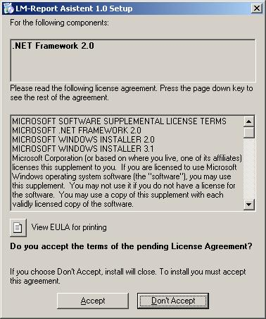

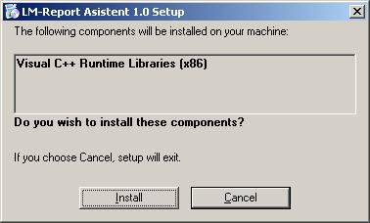

After confirming these dialogs, missing packages will be installed. If the installation of the packages fails (from any reasons) the Setup program will be aborted.

- Setup launches the LM-RA installer. The welcome dialog appears.

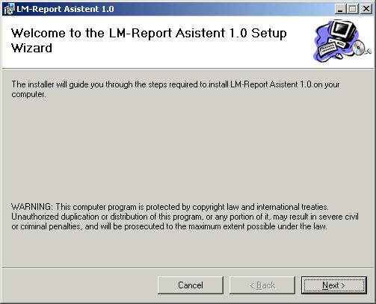

Click the “Next” button to continue the installation process.

- The “License Agreement” dialog appears.

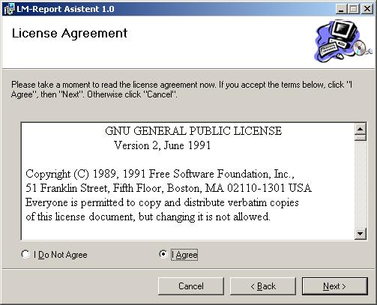

It is necessary to agree with the license (check the “I Agree” radio button) to continue the installation process. To continue the installation, press the “Next” button.

- The “Confirm Installation” dialog appears.

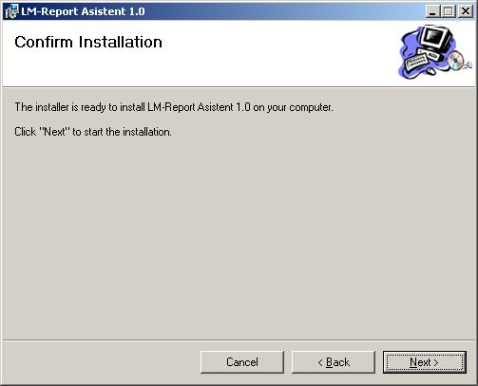

Press the “Next” button to confirm the installation.

- The “Sellect Installation Folder” dialog appears.

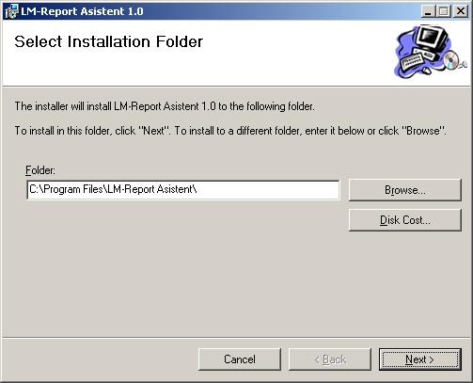

Choose the location, where the application will be installed. Then press the “Next” button to start the installer.

- LM-RA is being installed. You can see the progress of the installation in progress bar.

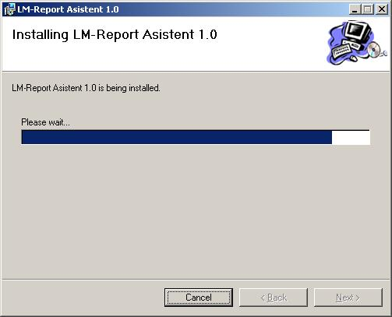

- If no problems occur during the installation (e.g. you don’t have sufficient privileges to install programs on the computer) and program was installed successfully, the following “Installation Complete” dialog should appear.

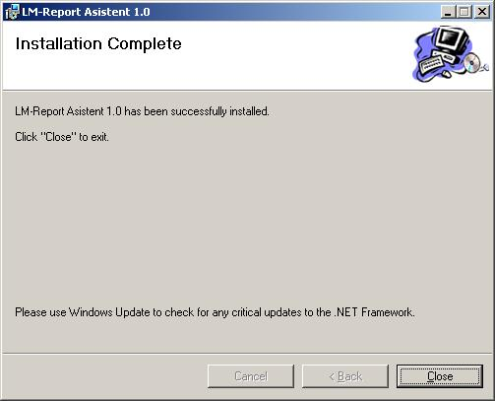

The setup is complete, press the “Close” button to close the dialog.

Launching the LM-RA program

When LM-RA is installed, it creates a shortcut on user’s desktop and also “LM-Report Asistent” folder in Start menu->Programs.
TODO: screenshot

Uninstalling LM-RA

Uninstalling of the application should be performed via “Add or Remove Programs” tool in “Control Panel” folder in Microsoft Windows system.
Search the item with name “LM-Report Asistent 1.0”, mark it and press the “Remove” button. LM-RA will be removed from your computer.

